**Building a Bird’s Nest**

Dominick Tota

University of Central Florida

April 16, 2014

**Abstract**

This project provides a summary of the main design considerations for China’s National Stadium, commonly referred to as “The Bird’s Nest.” A consortium consisting of Herzong & de Meron Architekete AG, Arup, and China Architecture Design and Research Group designed the stadium with focus on creating the illusion of chaos through the use of the same dimensions for virtually every section. The stadium was also designed using performance-based design. By the end of this paper, the four goals of this project are fulfilled – (1) to look at how structure behave and consider alternative designs, (2) to give experience in presenting engineering information to both engineers and non-engineers, (3) to give tools and skills for writing technical reports, and (4) to learn how to research and gather key information. Articles in both *Civil Engineering* magazine and *The Arup Journal* formed the basis for this report.

**Introduction**

The purpose of this project is to report the design of China’s National Stadium, nicknamed “The Bird’s Nest.” By evaluating the design of this structure and creating this report, the structure’s behavior is examined, engineering material is professionally presented, technical writing skills are enhanced, and researching skills are practiced.

More specifically, The Bird’s Nest’s design is examined through seven different categories – structural members, member characteristics, load types, load analysis/specifications, structural analysis, connections, and miscellaneous factors. These seven categories provide a comprehensive summary of the structure and provide a glimpse into the ideas of the engineers who created the design.

China’s National Stadium was constructed between December 2003 and May 2008, and was used as the main stadium to host the 2008 Summer Olympics in Beijing, China. The stadium is called the “Bird’s Nest” for its appearance of tangled steel sections resembling the appearance of a bird’s nest. A consortium consisting of Herzon & de Meron Architekten AG, Arup, and China Architecture Design and Research Group created the design after winning a bid from the National Stadium Company, Ltd., Beijing.

**Structural Members**

Steel was chosen as the main material because China has a strong steel industry. Every member and connection was designed with this industry in consideration, which satisfied the National Stadium Company’s goal of creating a stadium that reflected Chinese culture and artistry.

The original design called for every steel section, including the primary columns, secondary members, and tertiary members to be a square hollow structural section (HSS) with dimensions of 1.2m X 1.2m X 10mm. This uniformity helps to create the illusion of a bird’s nest, making the primary, secondary, and tertiary members indistinguishable.

In an attempt to reduce cost, some of the members in the top of the roof trusses, which are not viewable from most of the stadium, were reduced to dimensions of 1m X 1m X 10mm. This slight difference is not too noticeable and saved the National Stadium Company a considerable amount of money.

The architectural restriction of keeping virtually every member the same dimensions led to some problems when the design was evaluated for seismic loading. However, the design consortium solved this problem by deciding to implement performance-based design.

**Load Types**

Live loads for the stadium include mainly the weight of the stadium’s maximum occupancy (91,000 people).

Dead loads considered during the design were the weight of the roof structure (42,000 metric tons) and the weight of the stadium (110,000 metric tons). During construction, an incident of structural failure at the Paris Charles de Gaulle International Airport caused the engineers to further evaluate the stadium’s design. After this evaluation, the original plan for a retractable roof was discarded, allowing for less steel, reducing dead loads by about thirty percent and cost by ten percent.

Wind loads, snow loads, and temperature loads were also considered during the design, but the engineers’ main concerns resided with seismic loading because of the stadium’s earthquake prone location.

**Load Analysis/Specifications**

Because of their great concern of earthquakes and the architectural limitations on member size, the stadium was designed using performance-based design. By using a computer program named CATIA, the design team was able to model and analyze failure modes. A panel of experts, consisting of structural engineers who specialize in long-span roof structures, then examined these analyses and compared them to the Chinese structural steel design code. This panel eventually moved to approve the design.

By using performance-based design, the overall cost of the stadium, plate thickness, and connection size were reduced. These reductions actually fail under specifications from the American Institute of Steel Construction, but pass under performance-based design codes.

**Member Characteristics**

The primary members of the Bird’s Nest comprise twenty-four columns and twenty-four roof trusses. These members are used to create portal frames that support the stadium’s loading. The layout of these frames is shown in Figure 1.

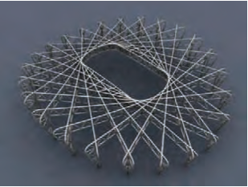

Fig. 1 – a view of the stadium’s primary members from above

When the stadium is subjected to loads other than earthquakes and wind, the twenty-four columns are mainly used as compression members. Under these same conditions, the members on the top of the roof trusses act as members in compression, while the bottom members experience tension.

If wind and seismic loads are considered, the main columns may be subjected to bending as well as compression.

The secondary and tertiary members, which are attached to the main columns and roof trusses, do not provide much structural support under normal loading conditions. However, during an earthquake, these members take most of the load and are designed for yielding. Due to this design, the primary members are designed to remain elastic.

Another function of the secondary and tertiary members are to provide support for the roof cladding, which protects the stadium seats from weather elements like rain, wind, sun. This cladding also helps to reduce noise pollution.

**Connections**

The main connections used in the “Bird’s Nest” concern double k-nodes, or nodes that connect primary column to primary truss members. Figure 3 shows an AutoCAD drawing of one of these connections:

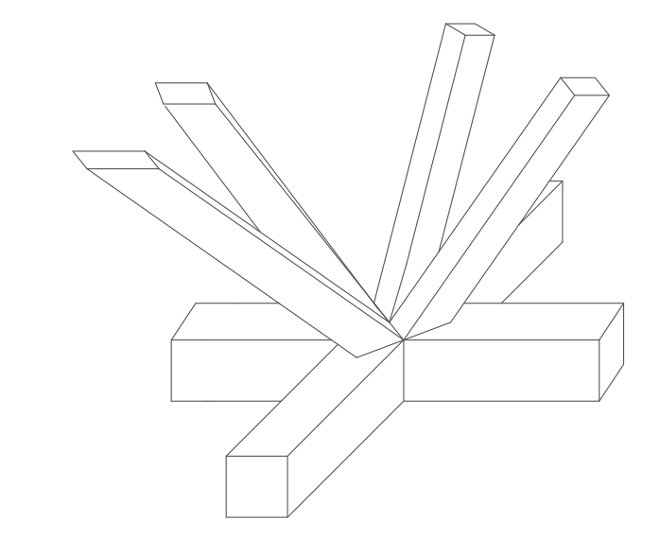

Fig. 3 – a double k-node connection

Another important connection used in the structure connects the sides of spokes members to inner columns. This type of connection is depicted in Figure 4.

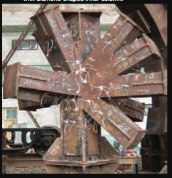

Fig. 4 – a spokes member to column connection

These above connections were extremely important to the structure’s design. To maximize the capacity of each of these connections, members were thickened and stiffener locations were chosen based on what would optimize strength.

**Structural Analysis**

In order to analyze the structure, Arup created a 3-D model in their computer program named *GSA*. The structure was modeled as a space frame and both a static and dynamic analysis was completed. They also analyzed the structure under three different classes of seismic loading, in addition to dead loads, live loads, snow loads, wind loads, and temperature loads.

After calculating the capacity of each member, the computer program was used to find and plot each member’s utilization ratio. This ratio was found under static conditions and is expressed as:

$$utility=\frac{force or load on member}{member^{'}s capacity}$$

Theoretically, this ratio should never exceed one because a value greater than one signifies a failure and requires the member to be redesigned. Figure 2 shows the results of this analysis that was performed:

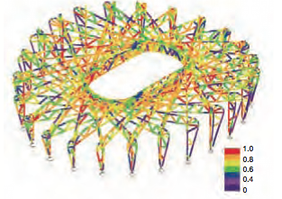Fig. 2 – the utilization ratio of each member

An analysis was also completed on each member during its construction, allowing the stadium to be safely and efficiently constructed. This analysis led to a four-phased construction.

The nodes, or places where multiple members are connected, were also analyzed. Because these members were assumed to behave elastic (the design was focused around this assumption), the stress distributions in each node were expressed in a von Mises diagram.

Prototype testing on the scale of 1:2.5 was also performed at two local universities to further analyze the structure for its safety.

**Summary/Conclusion**

China’s National Stadium, or “The Bird’s Nest,” is an innovative and unique structure. The stadium offers a great glimpse into performance-based design, which is slowly becoming more popular. By completing this project, I was able to learn more about performance-based design and how it is generally performed. This learning allowed me to complete the first goal of this project, which was to consider alternative designs. I was able to understand how the stadium behaves by examining Figure 2. This figure shows most of the members in a structure use only about 60 to 80% of their capacity, except for a few key sections that reach just under 100%. By this behavior, the first goal of understanding how structures behave was further fulfilled.

The second goal of this project was to gain experience in presenting engineering information to both engineers and non-engineers. By following the strict guidelines on the required sections and formatting provided, I was able to gain this experience. In order to make sure this project was suitable for a non-engineer audience, I had my uncle and mother, both of whom are not engineers, proofread this paper. Thus, I was able to complete goal two.

The third goal of this project was to gain exposure to technical writing and to the organization of engineering journals. By writing the paper, I was able to gain this technical writing experience. Also, by reading the articles and sources used to create this paper, I was able to learn how engineering journals are organized, fulfilling goal three.

The last goal of this project was to learn how to research and gather key information. By taking the time to find an article that seemed interesting and came from a reputable source, I was able to gain this research experience. I also learned how to gather key information by annotating and highlighting the main article on which this paper is based, satisfying goal four.

**Miscellaneous**

The roof cladding on the stadium was designed and built to consist of two membranes. The outer membrane is transparent and functions to protect the stadium from weather elements like rain and snow. The second membrane is an acoustic ceiling that reduces noise pollution, creates better sound for spectators, and protects the stadium against sunlight.

These two membranes are separated by about thirteen meters. The outer membrane is welded to the top chords of the roof truss, and the inner is suspended from the bottom chords of the truss.

Wind was also a concern during the design of the structure. The stadium hosts track and field events, and official rules demand that a runner’s time become invalid if there is wind in his or her running direction exceeding two meters per second. A study and analysis was completed of wind speed in the stadium’s location, and it was found that on average, less than seven percent of the time did wind speed in the stadium exceed this two meters per second. Therefore, the stadium was considered suitable for the track and field events. Also, this wind became a factor in maintaining turf grass quality.

Thermal comfort was also a variable to consider in the stadium’s design. The engineers did not want spectators or athletes in the stadium to be too hot or cold. In order to analyze this variable, the design team used Givoni’s thermal senstation index, which ranks thermal comfort on a scale of one to seven. A one corresponds to coolness and a seven corresponds to heat. After testing the stadium, the engineers found the average index number fluctuated between a four and a five, suggesting the stadium is thermally comfortable. A higher index was found in certain areas of the stadium, so changes, like increasing spacing between seats, were implemented to achieve comfortableness in these specific areas.

In an effort to fireproof the stadium, risky areas were fitted with sprinklers and smoke barriers. A performance-based analysis also led the engineers to fireproof only critical steel sections that are six meters or less from the spectators. Thus, most of the steel is not fireproofed.

**Sources/References**

Brown, J 2008, ‘Carrying the Torch’, *American Society of Civil Engineers*, Vol. 78, No. 8, pp. 48-55.

Burrows, S, Choi, T, Kwok, M, Parrish, J, Simpson, M, Lam, K, Lam, T, Duan, X, Ho, G, Lyle, J, Yin, R, Luo, M, Shiu, L, Shaw, J, Heide, RVDH & Kwok, M 2009, ‘The Beijing National Stadium’, *The Arup Journal: The Beijing National Stadium Special Issue*, No. 1, pp. 1- 52