Endless Pool® Design and Efficiency

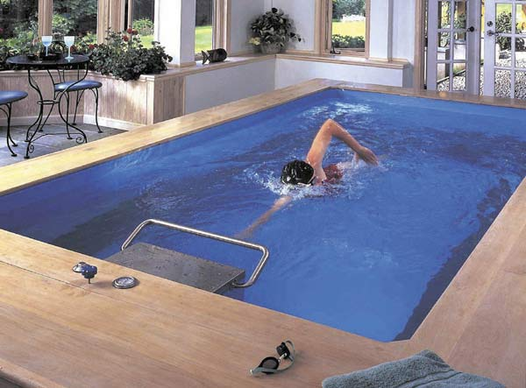

ARRMD
Dominick Tota (Project Manager)
Mark Bintz (Chief Editor)
Robert McLain
Andrew Gregg
Michael Grovac (withdrawn)

Date:
October 14, 2013

Instructor: Dr. Dennis Filler
Fluid Mechanics
CWR 3201
Section: 001

INTRODUCTION

The purpose of this report is to evaluate the design and efficiency of an Endless Pool. An Endless Pool, also called a swimming machine, is a type of above or in-ground pool in which water travels at a current proportional to a person’s swimming pace. This current allows the swimmer to “swim-in-place,” similar to a treadmill allowing a person to “walk-in-place.”
In particular, this report focuses on the “Elite” model of an Endless Pool, created by the company Endless Pools: Swimming Machines. This model has a water volume of 4,361 gallons and an exterior footprint of 18’ long by 8’6” wide at a standard model depth of 5’ (Endless pool available sizes and depths). In order to draw fair and realistic conclusions, analysis is compared to a Gunite in-ground lap pool with a volume of 18,225 gallons and a footprint of 50’ long by 14’ wide at a build depth of 6.5’. Through comparison, the efficiency and superiority of the Endless Pool product are demonstrated through design, cost, and improvement considerations.
The three main sections of this report are design analysis, efficiency analysis, and improvements/recommendations. Design analysis describes the functionality of an Endless Pool and presents its general specifications. Efficiency analysis examines the cost of constructing and maintaining the system and improvements/recommendations presents design changes that may increase efficiency. An appendix is also included at the end of the report to provide calculations for the values discussed within these sections.
This report should be considered in future Endless Pool construction to maximize profit and customer satisfaction. The conclusions reached may also be used to assist prospective buyers in choosing to purchase an Endless Pool product over a regular swimming or lap pool.

DESIGN ANALYSIS
The design of the “Elite” Endless Pool is intended to reduce the overall footprint that a full sized pool would create in a backyard. The “Elite” model has a footprint size of 153 square feet, while a Gunite lap pool has a size of 700 square feet. These numbers show that the Endless Pool’s footprint is about five times smaller than that of a lap pool (Endless pool available sizes and depths). Despite this significant size difference, the goal of providing adequate exercise and training to the user is still achieved through the Endless Pool’s water current system, demonstrated below:
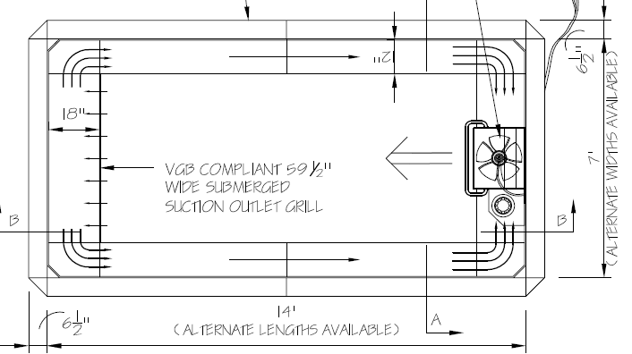
As the above diagram shows, the water current is created by an impellor. This impellor pushes water to the end of the pool, where it is then channeled back around the edges and fed back under side benches (Original endless pool (42” H panels shown)). The water is again fed through the impellor, creating a ceaseless current and producing a never-ending pool. Only 220V of electricity are required to power this system – an amount readily available at most residential dwellings.
Another feature of the “Elite” Endless Pool is its filtering and cleaning system. This continuously running Water Quality System involves the ionization of water, which inhibits bacterial growth and reduces the need for chemical treatment (Original endless pool poolside).
EFFICIENCY ANALYSIS
The cost efficiency of an Endless Pool comes from three parts – construction, operation, and maintenance. Average construction costs of an Endless Pool start at around $21,900. This price is about half that of a lap pool, which begins at around $50,000. Therefore, a customer can save around $28,100 in installation and construction by deciding to buy an Endless Pool over a lap pool (Endless pools vs. lap pools, 2013).
The cost of operating an Endless Pool is mainly electrical. Prices stem from two main components – the energy required to operate the Water Quality System and the electricity used to run the impellor. Using Endless Pool specifications, a simple calculation involving voltage, current, power, and the price of electricity, shows an operation cost of around $143 per year. Similar calculations of a lap pool yield around $217 per year – a 41% difference (Endless pools vs. lap pools, 2013). This does not take into account fuel charge, tax, franchise fee, or utility taxes.
Another cost of maintaining of an Endless Pool comes from the chemical treatment of the water, demonstrated by the following table:
Product | Price | Size | amt. | gal ⁻¹ | Cost | gals | wk. | Year
pH Plus | $16.99 | 10lb | 1lb | 10,000 | $1.70 | 4,361 | $0.74 | $39
pH Minus | $10.99 | 10lb | 1lb | 10,000 | $1.10 | 4,361 | $0.48 | $25
Clorox | $1.98 | 96oz | 4oz | 4,361 | $0.08 | 4,361 | $0.58 | $30
Nature²* | $72.49 | - | - | 10,000 | - | 4,361 | $4.53 | $236
 |  |  |  |  | Cost per Year** |  |  | $329

Nature² cartridge is an inline water sanitizing system. The copper silver minerals with chlorine ionize the water, which disinfects and prevents algae and bacterial growth.
Similar calculations of a lap pool yield results of $743 per year. Thus, an owner saves around $414 per year in maintaining an Endless Pool. These savings can be attributed to the ionization process, which decreases the amount of chemicals needed to effectively treat the water (Nature², 2013).
IMPROVEMENTS/RECOMMENDATIONS
A recommended improvement for the “Elite” Endless Pool concerns the shape of the system and the flow of water. The current design relies on sharp angles to direct the water around and underneath the benches; these sharp angles cause turbulent flow, decreasing the overall efficiency of the impellor (Murdock, 2013). If these sharp angles were reduced, the current induced by the impellor would become more efficient, requiring less power and saving the owner some electrical costs. However, these savings may be small in comparison to the amount of money an owner is already saving by choosing an Endless Pool.
In conclusion, the “Elite” Endless Pool is a superior product because it requires less space than a lap pool and costs less to construct, operate, and maintain. Due to the superior nature of this product, few recommendations can be made to make the Endless Pool more appealing and effective. A summary of the first year costs of both the Endless Pool and Lap Pool is given below:
Cost Comparisons of an Endless Pool with a Lap Pool
System | Up Front Cost ($) | Yearly Chemical Cost ($) | Yearly Electrical Cost ($) | Total Cost in First Year ($)
Lap Pool | 50,000 | 743 | 216.69 | 50,558.69
Endless Pool | 21,900 | 329 | 143.45 | 22,372.45
Savings | 28,100 | 414 | 73.24 | 28,587.24

As the above table shows, an owner can save roughly 50% in the first year of owning an Endless Pool, as compared to a traditional lap pool. Therefore, the “Elite” Endless Pool offers a efficient solution to the problems of pool size and budget.

Works Cited
Endless pool available sizes and depths, EP-1.1. Aston, PA: Endless Pools: Swimming Machines.
Endless pool limited warranty. Aston, PA: Fitness Machines.
Endless pool panel configurations, EP-1.0. Aston, PA: Endless Pools: Swimming Machines.
Endless Pools vs. lap Pools. (2013). Retrieved October 7, 2013 from www.endlesspools.com
Murdock, J. (2013). Endless pools: a complete line of swimming machines. Aston, PA: EPI Direct.
Murdock, J. Swim at home: today’s solution to better health and fitness. Aston, PA: Endless Pools: Swimming Machines.
Original endless pool planning guide. Aston, PA: EPI Direct.
Original endless pool poolside water quality system, EP-7.0. Aston, PA: Endless Pools: Swimming Machines.
Original endless pool (42” H panels shown), EP-1.3. Aston, PA: Endless Pools: Swimming Machines.
Permit considerations. Aston, PA: Endless Pools: Swimming Machines.
(2012, October). 2012 rate summary. Florida Power & Light Company, 24616. Retreived from www.fpl.com
(2013). Nature² the perfect swimming experience naturally. Vista, CA: Zodiac Pool Systems, Inc.

APPENDIX
Electrical costs calculations:
Endless Pool:
For the continuously running Water Quality System:
Power = IV = (0.8 amps)(220 V) = 176 W = .176 kW
$$\left(1 year\right)\left(\frac{365 days}{1 year}\right)\left(\frac{24 hours}{1 day}\right)\left(.176 kW\right)=\frac{1541.76 kWh}{year}$$
$$\left(\frac{1541.76 kWh}{year}\right)\left(\frac{6.184¢ }{kWh}\right)=\left(\frac{9534.24¢}{year}\right)\left(\frac{\$1}{100¢}\right)=\$95.34 per year$$
For the impellor:
$$P=IV=\left(17A\right)\left(220V\right)=3.74 kW$$
$$\left(\frac{1 hour}{day}\right)\left(\frac{4 days}{week}\right)\left(\frac{52 weeks}{1 year}\right)\left(3.74 kW\right)=\frac{777.92 kWh}{year}$$
$$\left(\frac{777.92 kWh}{year}\right)\left(\frac{6.184¢}{1 kWh}\right)\left(\frac{\$1}{100¢}\right)=\$48.11 per year$$

$$Electrical Cost per year=\$95.34+\$48.11=\$143.45$$

Lap Pool (assuming 1.2 kW pump and running eight hours per day):

$$\frac{8 hours}{day}\left(\frac{365 days}{1 year}\right)=\frac{2920 hours}{year}$$
$$\left(\frac{2920 hours}{year}\right)\left(1.2 kW\right)\left(\frac{6.184¢}{kWh}\right)\left(\frac{\$1}{100¢}\right)=\$216.69 per year$$

Chemical Costs of Lap Pool:
Lap Pool 12 x 45 x 4.5 ft. Volume = 18,225 gallons
Product | Price | Size | amt. | gal ⁻¹ | Cost | gals. | *adj. | wk. | Year
pH Plus | $16.99 | 10lb | 1lb | 10,000 | $1.70 | 18,225 | 18,796 | $3.19 | $166
pH Minus | $10.99 | 10lb | 1lb | 10,000 | $1.10 | 18,225 | 18,796 | $2.07 | $107
Cl | $10.99 | 32oz | 2oz | 10,000 | $4.81 | 18,225 | 18,796 | $9.04 | $470
 |  |  |  |  |  | **Cost per Year |  |  | $743

