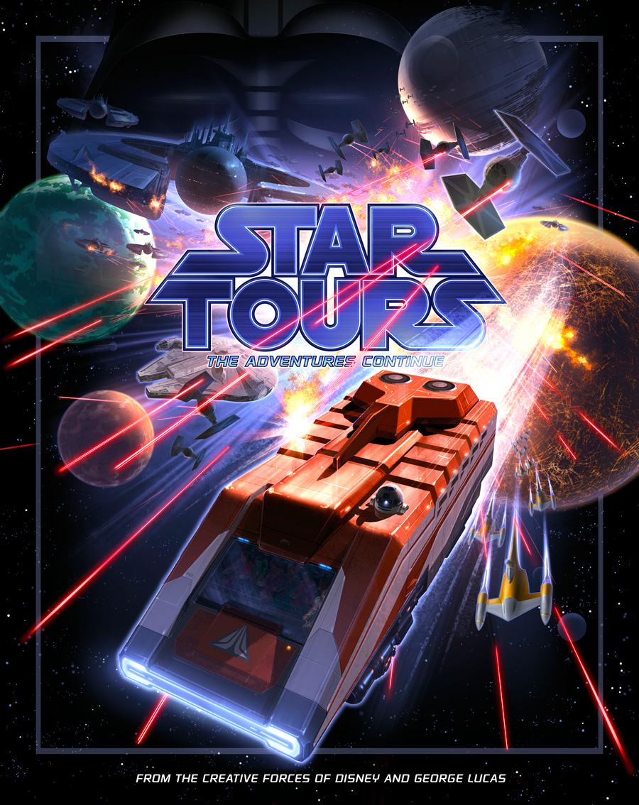
Dominick Tota
MAP 4113
Dr. Marianna Pensky
The Probability of Star Tours

TABLE OF CONTENTS

the history of star tours 2
Figure 1 2
Table 1 3
probabilities 4
Probabilities of Escape Sequence 4
Probabilities of First Planet Visited 5
Probabilities of Hologram Sequence 5
Probabilities of Last Planet Visited 5
Probabilities of More than One Event 6
Probabilities of Ride Vehicles 7
Probabilities of Reoccurring events 9

conclusion 9

Works cited 11

THE HISTORY OF STAR TOURS

Star Tours: The Adventures Continue is a high-tech, award-winning attraction located at Disney’s theme parks in Orlando, Florida; Anaheim, California; and Paris, France. The original ride, which had a shorter, simpler name of only Star Tours, first opened at Disneyland California in 1987 and was an instant success for being one of the first motion simulators. A motion simulator is a type of attraction in which guests ride a stationary vehicle and feel sensations of motion and traveling. Star Tours thrilled fans of George Lucas’ Star Wars saga by featuring characters and locations from the Star Wars films. Because of immense popularity, Disney constructed a sister version of the attraction at Disney’s Hollywood Studios in Orlando, Florida, in 1989 (“History of Star Tours” 9). In 2010, Disney announced the closure of all Star Tours attractions to make way for the debut of a redesigned, modern version of the attraction – renamed Star Tours: The Adventures Continue (Slate 31).

In 2011, Star Tours: The Adventures Continue, commonly referred to as Star Tours 2.0, opened to the public. This new version of the ride brought better graphics, enhanced simulator motion, and 3D picture to the guest’s entertainment. More recent elements from the Star Wars saga were also added to appeal to the franchise’s younger fans (Slate 31-32). Again, Disney completely reinvented the genre of motion-simulator-type attractions by implementing a brand new feature into the ride called “a random story system”. This system allows a computer to randomly generate different characters and events guests may encounter during the ride. There are four stages to this system – the escape sequence, the first planet visited, a hologram sequence, and the last planet visited. Below is a general summary of what occurs during each stage:
FIGURE 1
Escape Sequence

The ride vehicle narrowly escapes capture from an antagonist in the Star Wars saga.

Last Planet

The ride takes guests on an adventure to another planet from the Star Wars saga.
Hologram Sequence

Guests encounter a hologram of a protagonist from the Star Wars saga.

First Planet

The ride takes guests on an adventure to a planet from the Star Wars saga.
Escape From | Planet 1 | Hologram | Planet 2
Darth Vader | Hoth | Yoda | Coruscant
Darth Vader | Hoth | Yoda | Naboo
Darth Vader | Hoth | Yoda | Death Star
Darth Vader | Hoth | Ackbar | Coruscant
Darth Vader | Hoth | Ackbar | Naboo
Darth Vader | Hoth | Ackbar | Death Star
Darth Vader | Hoth | Leia | Coruscant
Darth Vader | Hoth | Leia | Naboo
Darth Vader | Hoth | Leia | Death Star
Darth Vader | Kashyyyk | Yoda | Coruscant
Darth Vader | Kashyyyk | Yoda | Naboo
Darth Vader | Kashyyyk | Yoda | Death Star
Darth Vader | Kashyyyk | Ackbar | Coruscant
Darth Vader | Kashyyyk | Ackbar | Naboo
Darth Vader | Kashyyyk | Ackbar | Death Star
Darth Vader | Kashyyyk | Leia | Coruscant
Darth Vader | Kashyyyk | Leia | Naboo
Darth Vader | Kashyyyk | Leia | Death Star
Darth Vader | Tatooine | Yoda | Coruscant
Darth Vader | Tatooine | Yoda | Naboo
Darth Vader | Tatooine | Yoda | Death Star
Darth Vader | Tatooine | Ackbar | Coruscant
Darth Vader | Tatooine | Ackbar | Naboo
Darth Vader | Tatooine | Ackbar | Death Star
Darth Vader | Tatooine | Leia | Coruscant
Darth Vader | Tatooine | Leia | Naboo
Darth Vader | Tatooine | Leia | Death Star
Stormtroopers | Hoth | Yoda | Coruscant
Stormtroopers | Hoth | Yoda | Naboo
Stormtroopers | Hoth | Yoda | Death Star
Stormtroopers | Hoth | Ackbar | Coruscant
Stormtroopers | Hoth | Ackbar | Naboo
Stormtroopers | Hoth | Ackbar | Death Star
Stormtroopers | Hoth | Leia | Coruscant
Stormtroopers | Hoth | Leia | Naboo
Stormtroopers | Hoth | Leia | Death Star
Stormtroopers | Kashyyyk | Yoda | Coruscant
Stormtroopers | Kashyyyk | Yoda | Naboo
Stormtroopers | Kashyyyk | Yoda | Death Star
Stormtroopers | Kashyyyk | Ackbar | Coruscant
Stormtroopers | Kashyyyk | Ackbar | Naboo
Stormtroopers | Kashyyyk | Ackbar | Death Star
Stormtroopers | Kashyyyk | Leia | Coruscant
Stormtroopers | Kashyyyk | Leia | Naboo
Stormtroopers | Kashyyyk | Leia | Death Star
Stormtroopers | Tatooine | Yoda | Coruscant
Stormtroopers | Tatooine | Yoda | Naboo
Stormtroopers | Tatooine | Yoda | Death Star
Stormtroopers | Tatooine | Ackbar | Coruscant
Stormtroopers | Tatooine | Ackbar | Naboo
Stormtroopers | Tatooine | Ackbar | Death Star
Stormtroopers | Tatooine | Leia | Coruscant
Stormtroopers | Tatooine | Leia | Naboo
Stormtroopers | Tatooine | Leia | Death Star
In total, there are 54 combinations of events that may occur during each ride. According to the www.thefable.co.uk, and through corroboration of my own experiences with the attraction, Table 1 (taken from The Fable) is a good summary of these combinations. On the next page is an explanation of how to read it.
TABLE 1
One should read Table 1 in a left-to-right manner. For example, the computer may first decide a vehicle will escape from Darth Vader, venture to Tatooine, experience an Ackbar hologram, and then travel to Coruscant. Events within columns cannot occur more than once during one ride. For instance, if the computer decides a vehicle will escape from Stormtroopers, that vehicle will not also escape from Darth Vader within the same ride.

Generally, guests have many questions concerning the nature of Star Tours: The Adventures Continue. Some of them are:

- How likely am I to travel to Hoth?
- What is the probability of encountering Yoda?
- What are the chances of me going on the ride twice and witnessing the same combination of events?

The answers to these questions, and many more, will be presented throughout the remainder of this report.

PROBABILITIES
In the following calculations, unless otherwise noted, the computer’s random selection of events is assumed to behave independently. Table 1 will also act as the sample space of the experiment, and the word “ride” will be used to mean one application of the random story system through its entirety.

PROBABILITies OF ESCAPE SEQUENCE

The probabilities of escape sequence events occurring in one vehicle during one ride are easily found using the classical definition of probability:

$$P=\frac{\# Favorable Outcomes}{\# Possible Outcomes}$$

Using this formula,

$$P\left(Darth Vader\right)= \frac{27}{54}=\frac{1}{2}$$

$$P\left(Stormtroopers\right)= \frac{27}{54}=\frac{1}{2}$$

PROBABILITiES OF FIRST PLANET VISITED

The probabilities of the first planet visited in one vehicle during one ride are found using the Law of Total Probability:

$$P\left(Hoth\right)=P\left(Hoth | Darth Vader\right)P\left(Darth Vader\right)+ P\left(Hoth | Stormtroopers\right)P(Stormtroopers)$$

$$P\left(Hoth\right)=\left(\frac{9}{27}\right)\left(\frac{1}{2}\right)+\left(\frac{9}{27}\right)\left(\frac{1}{2}\right)=\frac{1}{3}$$

The probabilities of Kashyyyk and Tatooine are found in the same manner, with the following results:

$$P\left(Kashyyyk\right)=\frac{1}{3}$$

$$P\left(Tatooine\right)=\frac{1}{3}$$

PROBABILITiES OF HOLOGRAM SEQUENCE

The probabilities of the Hologram Sequence in one vehicle during one ride are also found using an application of the Law of Total Probability:

$$P\left(Yoda\right)=P\left(Yoda | Hoth\right)P\left(Hoth\right)+ P\left(Yoda | Kashyyk\right)P\left(Kashyyyk\right)+ P\left(Yoda | Tatooine\right)P(Tatooine)$$

$$P\left(Yoda\right)=\left(\frac{3}{9}\right)\left(\frac{1}{3}\right)+\left(\frac{3}{9}\right)\left(\frac{1}{3}\right)+\left(\frac{3}{9}\right)\left(\frac{1}{3}\right)=\frac{1}{3}$$

Following these calculations similarly for Leia and Ackbar yields:

$$P\left(Leia\right)=\frac{1}{3}$$

$$P\left(Ackbar\right)= \frac{1}{3}$$

PROBABILITiES OF THE LAST PLANET VISITED

The probabilities of the last planet visited in one vehicle during one ride are again found using the law of total probability:

$$P\left(Coruscant\right)=P\left(Coruscant | Yoda\right)P\left(Yoda\right)+P\left(Coruscant | Leia\right)P\left(Leia\right)+ P\left(Coruscant | Ackbar\right)P(Ackbar)$$

$$P\left(Coruscant\right)=\left(\frac{1}{3}\right)\left(\frac{1}{3}\right)+\left(\frac{1}{3}\right)\left(\frac{1}{3}\right)+\left(\frac{1}{3}\right)\left(\frac{1}{3}\right)=\frac{1}{3}$$
Similarly,

$$P\left(Naboo\right)=\frac{1}{3}$$
$$P\left(Death Star\right)=\frac{1}{3}$$

Thus, there is a one third chance that a guest will encounter any event during a ride, except for Darth Vader and the Stormtroopers, which both have a probability of one half.

PROBABILITiES OF MORE THAN ONE EVENT

Now that the probabilities of each event have been found, the chances of more than one event occurring can be calculated. Through the definition of independence, it can be shown that if A and B are independent events, then

$$P\left(AB\right)=P\left(A\right)P(B)$$

Let A be the event of a specific escape sequence occurring, B the event of a specific first planet visited, C the event of a specific hologram sequence, and D the event of a specific last planet visited. One can find the following probabilities:

$$P\left(AB\right)=P\left(A\right)P\left(B\right)=\left(\frac{1}{2}\right)\left(\frac{1}{3}\right)=\frac{1}{6}$$

$$P\left(ABC\right)=P\left(A\right)P\left(B\right)P\left(C\right)=\left(\frac{1}{2}\right)\left(\frac{1}{3}\right)\left(\frac{1}{3}\right)=\frac{1}{18}$$

$$P\left(ABCD\right)=P\left(A\right)P\left(B\right)P\left(C\right)P\left(D\right)=P\left(A\right)P\left(B\right)P\left(C\right)P\left(D\right)=\left(\frac{1}{2}\right)\left(\frac{1}{3}\right)\left(\frac{1}{3}\right)\left(\frac{1}{3}\right)=\frac{1}{54}$$

From these calculations one can find the probabilities of any specific amount of events occurring during a ride. For example:

$$P\left(Darth Vader and Hoth\right)=P\left(AB\right)=\frac{1}{6}$$

$$P\left(Stormtroopers and Kashyyyk and Yoda and Death Star\right)=P\left(ABCD\right)=\frac{1}{54}$$

$$P\left(Stormtroopers and Leia\right)=P\left(AC\right)=P\left(A\right)P\left(C\right)=\left(\frac{1}{2}\right)\left(\frac{1}{3}\right)=\frac{1}{6}$$

$$P\left(Hoth and Not Naboo\right)=P\left(B\right)P\left(D^{C}\right)=P\left(B\right)\left(1-P\left(D\right)\right)=\left(\frac{1}{3}\right)\left(\frac{2}{3}\right)=\frac{2}{9}$$

These above results can be extended to any combinations of events one may desire within a ride.

Probabilities of ride vehicles

The arrangement of Star Tours: The Adventures Continue also has some associated probabilities. There are six vehicles at Disney’s Hollywood Studios, and each vehicle independently partakes in the random story system at the same time. If one considers only one application of the story system among all six vehicles, the following probabilities can be found:

$$P\left(each vehicle has a different ride\right)=\left(\frac{54}{54}\right)\left(\frac{53}{54}\right)\left(\frac{52}{54}\right)\left(\frac{51}{54}\right)\left(\frac{50}{54}\right)\left(\frac{49}{54}\right)=0.7499748064$$

$$P\left(each vehicle has the same ride\right)=\frac{54}{{54}^{6}}=2.177866231\left({10}^{-9}\right)$$

$$P\left(at least two vehicles have the same ride\right)=1-P\left(all different\right)=1-0.7499748064=0.2500251936$$

Furthermore, if a specific ride is chosen, (say Stormtroopers, Hoth, Yoda, and Coruscant as an example) then a discrete random variable, X, with binomial distribution and parameters n=6 and p=1/54 can be established. (Success is when this ride occurs.) Thus, one can find the following probabilities:

$$P\left(X=0\right)=\left(\begin{matrix}6 \\ 0\end{matrix}\right){\left(\frac{1}{54}\right)}^{0}{\left(\frac{53}{54}\right)}^{6}=0.8939076597$$
$$P\left(X=1\right)=\left(\begin{matrix}6 \\ 1\end{matrix}\right){\left(\frac{1}{54}\right)}^{1}{\left(\frac{53}{54}\right)}^{5}=0.1011970936$$
$$P\left(X=2\right)=\left(\begin{matrix}6 \\ 2\end{matrix}\right){\left(\frac{1}{54}\right)}^{2}{\left(\frac{53}{54}\right)}^{4}=0.0047734478$$
$$P\left(X=3\right)=\left(\begin{matrix}6 \\ 3\end{matrix}\right){\left(\frac{1}{54}\right)}^{3}{\left(\frac{53}{54}\right)}^{3}=1.200867373\left({10}^{-4}\right)$$
$$P\left(X=4\right)=\left(\begin{matrix}6 \\ 4\end{matrix}\right){\left(\frac{1}{54}\right)}^{4}{\left(\frac{53}{54}\right)}^{2}=1.699340623\left({10}^{-6}\right)$$
$$P\left(X=5\right)=\left(\begin{matrix}6 \\ 5\end{matrix}\right){\left(\frac{1}{54}\right)}^{5}{\left(\frac{53}{54}\right)}^{1}=1.282521225\left({10}^{-8}\right)$$
$$P\left(X=6\right)=\left(\begin{matrix}6 \\ 6\end{matrix}\right){\left(\frac{1}{54}\right)}^{6}{\left(\frac{53}{54}\right)}^{0}=4.03308561\left({10}^{-11}\right)$$

From these calculations one can find the following quantities:

$$EX=\left(0\right)\left(0.8939076597\right)+\left(1\right)\left( 0.1011970936\right)+\left(2\right)\left(0.0047734478\right)+\left(3\right)\left(1.200867373\left({10}^{-4}\right)\right)+\left(4\right)\left(1.699340623\left({10}^{-6}\right)\right)+\left(5\right)\left(1.282521225\left({10}^{-8}\right)\right)+\left(6\right)\left(4.03308561\left({10}^{-11}\right)\right)=0.111111111$$

$$E\left(X^{2}\right)={\left(0\right)}^{2}\left(0.8939076597\right)+{\left(1\right)}^{2}\left( 0.1011970936\right)+{\left(2\right)}^{2}\left(0.0047734478\right)+{\left(3\right)}^{2}\left(1.200867373\left({10}^{-4}\right)\right)+{\left(4\right)}^{2}\left(1.699340623\left({10}^{-6}\right)\right)+{\left(5\right)}^{2}\left(1.282521225\left({10}^{-8}\right)\right)+{\left(6\right)}^{2}\left(4.03308561\left({10}^{-11}\right)\right)=0.121399177$$

$$Var\left(X\right)=E\left(X^{2}\right)-{\left(EX\right)}^{2}=0.121399177-{0.111111111}^{2}=0.109053498$$

$$σ\left(X\right)=\sqrt{Var(X)}=\sqrt{0.109053498}=0.3302324908$$

These above quantities show that the expected number of vehicles to have one specific ride from Table 1, is 0.111111111 and the standard deviation of this distribution is 0.3302324908. This is a very small number and suggests the computer is highly unlikely to distribute any one specific ride to the vehicles during one application of the random story system.

These ideas can also be applied to events that occur within the random story system. For instance, one can evaluate the event of Leia’s hologram appearing among the vehicles by creating another discrete random variable, Y. Y has parameters n=6 and p=1/3. (Success is the Leia event occurring.) Thus, Y has the following probability mass function:

$$P\left(Y=k\right)=\left(\begin{matrix}6 \\ k\end{matrix}\right){\left(\frac{1}{3}\right)}^{k}{\left(\frac{2}{3}\right)}^{6-k}, for k=0,1,2,3,4,5,6$$

From this function, EY, Var(Y), and σ(Y) can be found. Instead of going through and evaluating for each value of Y as before, one can use a shortcut:

$$EY=np=\left(6\right)\left(\frac{1}{3}\right)=2$$

$$Var\left(Y\right)=npq=6\left(\frac{1}{3}\right)\left(1-\frac{1}{3}\right)=1.333333333$$

$$σ\left(Y\right)=\sqrt{Var(Y)}=\sqrt{1.333}=1.154700538$$

These quantities show that the expected number of vehicles to have a hologram visit from Princess Leia during one ride among all six vehicles is 2. This distribution has a standard deviation of 1.154700538.

It should also be noted that the above calculations only hold for Star Tours 2.0 in Disney’s Hollywood Studios. In California and Paris, there are four vehicles instead of six (History of Star Tours 9). Therefore, these probabilities would still be found in the same manner, but the parameters would slightly differ.

PROBABILITIES OF REOCCURRING RIDES

The chances of a guest riding Star Tours 2.0 twice and witnessing the same combination of events both times can easily be found through the assumption of independence. The first time he or she rides has 54 choices of rides, and the second has only one. In total, there are 54 choices for each time he or she rides. Thus,

$$P\left(same ride twice\right)=\left(\frac{54}{54}\right)\left(\frac{1}{54}\right)=\frac{1}{54}≈1.85\%$$

This result can be extended to a guest riding Star Tours: The Adventures Continue n times:

$$P\left(n same rides\right)=\left(\frac{54}{54}\right){\left(\frac{1}{54}\right)}^{n-1}$$

These calculations show that there is a really low chance of a guest receiving the same experience each time he or she rides the attraction.

CONCLUSION

Star Tours: The Adventures Continue is a unique Disney attraction that associates the popularity of George Lucas’s Star Wars saga with the genre of motion simulator rides. Star Tours 2.0 completely reinvented this genre of amusement park ride through implementation of a random story system, which allows a computer to randomly choose the occurrence of events during the ride. In this paper, the probabilities associated with this system were evaluated and presented. The chances of the computer’s pick for each part of the system were shown, the probabilities of more than one choice were calculated, the likelihoods of more than one vehicle experiencing the same ride were evaluated, and the chances of a guest receiving the same experience each ride were also found. These probabilities demonstrate that each guest’s experience with Star Tours: The Adventures Continue is indeed unique; virtually every ride is different.

works cited

Ghahramani, Saeed. Fundamentals of Probability with Stochastic Processes. Upper Saddle River, NJ: Pearson/Prentice Hall, 2005. Print.
"History of Star Tours." History of Star Tours. 2012-2013. Web. 04 Mar. 2013. <www.studioscentral.com>.
Slate, Libby. "Tour De Force." Live Design May 2012: 30-33. Print.
Steve. "All 54 of the Star Tours 2 Ride Combinations | Fabled Thoughts." Fabled Thoughts. 24 May 2011. Web. 04 Mar. 2013. <www.thefable.co.uk>.

